

SCHOOL OF COMPUTER SCIENCE AND ENGINEERING

India Electricity Demand, Generation & Energy Mix Forecast

TIME SERIES ANALYSIS AND FORECASTING
(CS3216) 2026-2027

Submitted by
Name 1 – B N Suhas USN: 1RUA24CSE0079
Name 2 – Lalith Kumar G N USN: 1RUA24CSE0222
Name 3 – Madhusudhan C USN: 1RUA24CSE0234
Name 4 – N A Harshal USN: 1RUA24CSE0269
Name 5 – Ponnu Krishna M.P USN: 1RUA24CSE0301

Under the guidance of
Prof. Prashant Adhikari
School of Computer Science and Engineering
RV University-560059
RV UNIVERSITY, BENGALURU-59

SCHOOL OF COMPUTER SCIENCE AND ENGINEERING

CERTIFICATE

Certified that the project work titled India Electricity Demand, Generation & Energy Mix Forecast is carried out by B N Suhas (1RUA24CSE0079), Lalith Kumar G.N (1RUA24CSE0222), Madhusudhan C (1RUA24CSE0234), N A Harshal (1RUA24CSE0269), Ponnu Krishna M.P (1RUA24CSE0301) in partial fulfilment of the completion of the course TIME SERIES ANALYSIS AND FORECASTING with course code CS3216 of the V Semester Computer Science Engineering programme, during the academic year 2026-2027. It is certified that all corrections/suggestions indicated for the Internal Assessment have been incorporated in the project report and duly approved by the faculty.

Signature of Faculty
Table of Contents

Abstract 1

1. Introduction 2

1.1 Overview of Project 2

1.2 Objective of the Project 2

1.3 Scope of the Project 3

2. System Analysis 4

2.1 Problem Statement 4

2.2 Functional Requirements 5

2.3 Non-Functional Requirements 6

3. System Design 7

3.1 System Architecture 7

3.2 UML Diagrams (Use Case, Activity) 8

3.3 Dataset and Data Design 10

4. Tools and Technologies 12

4.1 Programming Language - Python 12

4.2 Development Environment 12

4.3 Data Storage - CSV / pandas 12

4.4 Libraries and Technologies Used 12

5. Implementation 13

5.1 Project Modules 13

5.2 Data Consolidation and Cleaning 13

5.3 Exploratory Analysis 14

5.4 Feature Engineering 16

5.5 Forecasting Models and Evaluation 16

5.6 Forecast to 2040 and Demand-Supply Gap 18

5.7 Dashboard 19

6. Testing 20

6.1 Test Cases 20

6.2 Results and Debugging 21

7. Conclusion 22

7.1 Summary 22

7.2 Future Enhancements 22

8. References 24

ABSTRACT
India’s electricity demand rises every year, driven by cooling, industry and population growth, and power plants must generate enough to meet it or the grid faces shortfalls and outages. Planners need forecasts that show not only what demand and generation are likely to be, but also how far those numbers can be trusted. This project builds a time series forecasting system for India’s electricity demand, generation and energy mix from 2013 to 2040, and uses it to ask whether supply will keep pace with demand.
The system combines five public datasets from the Central Electricity Authority (CEA), Grid India and IMD-derived temperature records: daily generation by source, daily state-wise demand, hourly national and regional load, state-wise consumption, and monthly temperature. Before any modelling, the data was audited and four problems were found and corrected: double counting caused by a change in CEA’s reporting format, a reporting blackout around May 2017, uneven day coverage that produced a false 630% year-on-year spike, and missing coal data that made renewables appear to collapse. The cleaned data was consolidated into one monthly table using average daily values and day-coverage flags.
The series was studied with seasonal decomposition and year-on-year growth analysis. These revealed a strong yearly cycle that peaks in summer, a steady upward trend, a sharp COVID-19 dip of about 24% in April 2020, and a renewables share that rose from 7.6% to 11.2% between December 2018 and March 2023. Six forecasting models, from naive baselines to Holt-Winters, ARIMA and SARIMA, were compared using walk-forward validation, with MAE, RMSE and MAPE measured at horizons of 1 to 24 months. The SARIMA order was tuned with an AIC search over 36 candidates, and the selected model forecasts demand and generation to 2040 with 95% prediction intervals.
Subtracting demand from generation gives the demand-supply gap, shown with worst-case and best-case ranges. Because only horizons up to about 24 months were tested against history, later years are presented as trend-based scenarios, not precise predictions. All results are available in an interactive Streamlit dashboard with four tabs, including a scenario slider for generation growth.

1. INTRODUCTION
1.1 Overview of Project
This project is a time series forecasting system for India’s electricity sector. It uses historical records from the Central Electricity Authority (CEA) and Grid India to forecast how much electricity India will demand and generate up to 2040. It then compares the two forecasts to answer one question: will India’s power plants keep up with demand?
Electricity data is a time series with clear structure. Demand peaks every summer when cooling load rises, it climbs year after year with economic and population growth, and it can be disturbed by sudden events such as the COVID-19 lockdown of 2020, when demand fell by about 24% compared with the previous year. Generation follows a similar pattern, and the mix of sources behind it is slowly shifting. The share of renewables rose from about 7.6% in December 2018 to about 11.2% in March 2023.
Raw government data cannot be fed straight into a forecasting model. The five datasets used here come from different sources, cover different periods, and change reporting format partway through. Handling this was a large part of the work, so the project treats data auditing as a core step. The pipeline has eight stages:
- Consolidating the five raw files into one monthly table.
- Exploratory analysis of trend, seasonality, growth and source mix.
- Preparing the series for modelling.
- Comparing six forecasting models.
- Tuning the SARIMA model.
- Forecasting demand and generation to 2040 with 95% prediction intervals.
- Computing the demand-supply gap.
- Presenting everything in an interactive dashboard.
The project uses core time series techniques throughout: resampling to monthly averages, handling missing data, seasonal decomposition, year-on-year growth analysis, walk-forward validation at several horizons, SARIMA modelling with AIC-based order selection, and prediction intervals.
1.2 Objective of the Project
The main objective is to forecast India’s electricity demand and generation to 2040, compare them, and state clearly how far the numbers can be trusted. The specific objectives are:
- To consolidate five public datasets (daily generation by source, daily state demand, hourly load, state consumption and monthly temperature) into one clean monthly table.
- To audit the raw data for errors such as double counting, reporting gaps and uneven coverage, and to correct them so that they do not distort the analysis.
- To analyse the series with decomposition and year-on-year growth to understand its trend, seasonality and unusual events.
- To track how the generation mix (coal, renewables, hydro, nuclear and gas) has changed over time.
- To compare six forecasting models using walk-forward validation, measured with MAE, RMSE and MAPE.
- To measure how forecast accuracy falls as the horizon grows from 1 to 24 months.
- To select the SARIMA order by an AIC search and forecast demand and generation to 2040 with 95% prediction intervals.
- To compute the demand-supply gap, with worst-case and best-case ranges.
- To present the results in an interactive dashboard, including a scenario slider for generation growth.
1.3 Scope of the Project
The project covers the full forecasting workflow at the national level: data consolidation, cleaning, exploratory analysis, model comparison, tuning, long-range forecasting, gap analysis and a dashboard. It uses only public data: CEA daily generation by source (2013–2023), daily state-wise demand and energy met (2013–2023), hourly national and regional load (2019–2024), state-wise consumption (2013–2024) and monthly temperature (2019–2021).
Forecasts are made at monthly resolution, as average daily values in million units (MU) per day, from the end of the data to December 2040. Demand is measured as energy met, which is the electricity actually supplied. Analysis of the generation mix is limited to December 2018 onward, because CEA’s itemised coal and lignite figures are not reliable before then.
The accuracy of the forecasts depends on the quality and continuity of the source data, and several limits apply:
- Only horizons of up to about 24 months were tested against history. Forecasts beyond that are trend-based scenarios, not precise predictions, and their prediction intervals widen sharply.
- The temperature data covers only 36 months, so it supports a correlation analysis (r = 0.37) but not a long-range forecast.
- The worst-case and best-case gap ranges treat demand and generation uncertainty as independent, which probably overstates the worst case because the two series move together.
- The model does not include policy changes or planned capacity additions. The dashboard’s growth slider is an illustration only and does not re-fit the model.

2. SYSTEM ANALYSIS
2.1 Problem Statement
India’s electricity demand grows every year. Cooling load, industry and a growing population push consumption up, with a peak each summer. Power plants must generate enough to meet this demand, or the grid faces shortfalls and outages. Planning new capacity takes years, so planners need to know well in advance whether supply is likely to keep pace.
The raw data needed to answer this is published by the Central Electricity Authority (CEA) and Grid India, but it is not ready for forecasting. It is split across several files with different coverage periods, and CEA’s reporting format changed partway through the record. Some months are barely reported at all. Used carelessly, this data produces confidently wrong results, such as a false 630% growth spike or a renewable-energy collapse that never happened.
The problem is to turn this raw, inconsistent data into a reliable forecast of demand and generation up to 2040, to compare the two, and to say clearly how far the numbers can be trusted.
At present, the electricity data used for planning is mostly available as historical reports and downloadable daily files. These sources answer the question “how much electricity was generated or demanded?” but not “will supply keep up with demand in the years ahead?”. They have these limitations:
- They report past values and give no forecast of future demand and generation.
- Generation, state demand, hourly load and consumption sit in separate files with different date ranges, so there is no single consistent series.
- The reporting format changes over time, so parent categories (Thermal, RES) and their parts (Coal, Wind, Solar) appear on different dates. Simply adding them up double counts.
- Several months are under-reported, which distorts growth rates and trends if not detected.
- Past records come with no measure of uncertainty, so a reader cannot judge how much to trust a long-range number.
- Demand and generation are not compared in one place as a gap that can be tracked over time.
Proposed System
The proposed system turns the raw files into a clean monthly time series, forecasts it, and presents the result as a demand-supply gap. It works in eight stages:
- Consolidate the five raw files into one monthly master table, using average daily values and a days-reported count so that uneven coverage cannot distort the data.
- Audit and correct the data: the reported Total is used as published and never recomputed, one category level is chosen per date, and gaps are treated as missing, not zero.
- Explore the series with seasonal decomposition, year-on-year growth, source-mix analysis, a demand-temperature correlation and a peak-versus-average demand comparison.
- Prepare a model-ready series in which unreliable months are interpolated and the COVID-19 period is flagged.
- Compare six forecasting models with walk-forward validation at horizons of 1 to 24 months.
- Tune the SARIMA model with an AIC search over 36 candidate orders.
- Forecast demand and generation to 2040 with 95% prediction intervals, and separate the first 24 months (backed by validation) from later years (shown as trend-based scenarios).
- Present the results in an interactive Streamlit dashboard, with the demand-supply gap and a scenario slider for generation growth.
2.2 Functional Requirements
The functional requirements describe the main operations that the system should perform.
- Data Ingestion: Read the five source files (daily generation by source, daily state demand, hourly load, state consumption and monthly temperature) and standardise column names, dates and source labels.
- Hierarchy-Aware Harmonisation: Build one continuous series per energy source (coal and lignite, renewables, hydro, nuclear, gas) across the CEA reporting-format change, without double counting.
- National Aggregation: Sum state-level energy met into national daily demand, and summarise hourly load into daily mean, maximum and minimum.
- Monthly Aggregation: Convert daily values into monthly average daily values and record the number of days reported for each metric.
- Coverage Flagging: Mark any month with fewer than 20 reported days in a core metric as low-coverage.
- Exploratory Analysis: Produce decomposition into trend, seasonality and residual; year-on-year growth; source-mix evolution; demand-temperature correlation; and the peak-versus-average demand gap.
- Missing Data Handling: Interpolate low-coverage months in the target series so the monthly index stays continuous.
- Model Comparison: Evaluate Naive, Seasonal Naive, Moving Average, Exponential Smoothing, ARIMA and SARIMA models with walk-forward validation, using MAE, RMSE and MAPE.
- Multi-Horizon Evaluation: Measure forecast error at 1, 3, 6, 12 and 24 months ahead.
- Model Tuning: Search SARIMA orders and select the one with the lowest AIC.
- Long-Range Forecasting: Forecast average daily demand and generation to December 2040 with 95% prediction intervals, and mark which months fall inside the validated horizon.
- Gap Analysis: Compute generation minus demand, with worst-case and best-case ranges, at selected checkpoint years (2026, 2030, 2035, 2040).
- Dashboard: Show historical trends, source mix, the forecasts and the gap in four interactive tabs, with a slider to explore faster or slower generation growth.
2.3 Non-Functional Requirements
The non-functional requirements describe the expected quality and behaviour of the system.
- Data Integrity: Raw data is never altered. CEA’s reported Total is used as published, and every cleaning step is documented and can be audited.
- Honest Handling of Gaps: Missing or under-reported data must be marked as missing, never counted as zero, and must not silently distort growth rates or shares.
- No Data Leakage: Models are always trained on earlier data and tested on later data. Time is never shuffled.
- Baseline Comparison: Every model is judged against simple naive baselines, so that added complexity must justify itself.
- Transparent Uncertainty: Every forecast is shown with a prediction interval, and forecasts beyond the validated horizon are labelled as scenarios.
- Reproducibility: The full pipeline is scripted in Python, and every output file can be regenerated from the raw data with the documented run order.
- Interpretability: Results are shown as clear charts and tables, with the demand-supply gap stated as a single understandable quantity (surplus or shortfall in MU per day).
- Usability: The dashboard is readable without technical knowledge and loads its data once and caches it.
- Extensibility: The same code runs for generation, demand or consumption by changing a single target setting, and new data files can be added at the consolidation stage.

3. SYSTEM DESIGN
3.1 System Architecture
The system follows a pipeline architecture in eight steps. Steps 1 to 4 turn five raw government files into one clean monthly time series. Steps 5 to 8 forecast that series, compare supply with demand, and present the results. Each step reads the output of the one before it, and the raw data is never modified.
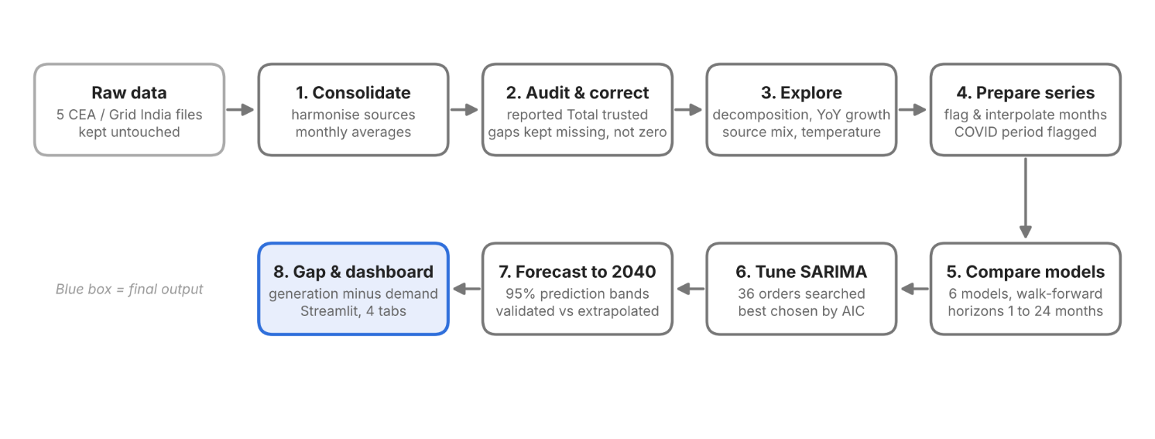
Figure 3.1: System architecture - the India electricity forecasting pipeline
The main layers of the system are:
- Data Layer: Holds the five raw files (daily generation by source, daily state demand, hourly load, state consumption and monthly temperature). These are kept untouched so that every later step can be audited.
- Consolidation and Cleaning Layer: Standardises names and dates, builds one continuous series per energy source across the CEA reporting-format change, aggregates daily values to monthly averages, and flags months with too few reported days.
- Analysis Layer: Studies the monthly series with seasonal decomposition, year-on-year growth, source-mix evolution, a demand-temperature correlation and a peak-versus-average demand comparison.
- Modelling Layer: Prepares the target series, compares six forecasting models with walk-forward validation at several horizons, tunes the SARIMA order, and forecasts demand and generation to 2040.
- Presentation Layer: Computes the demand-supply gap and shows the history, source mix, forecasts and gap in an interactive Streamlit dashboard.

3.2 UML Diagrams
Use Case Diagram
The Use Case Diagram shows the main interactions with the system. The data sources (CEA and Grid India files) supply the raw data. The data analyst loads and cleans the data, builds the monthly table, explores the trends, compares and tunes the models, and generates the 2040 forecast. The energy planner views the dashboard, reads the demand-supply gap and adjusts the generation-growth scenario.
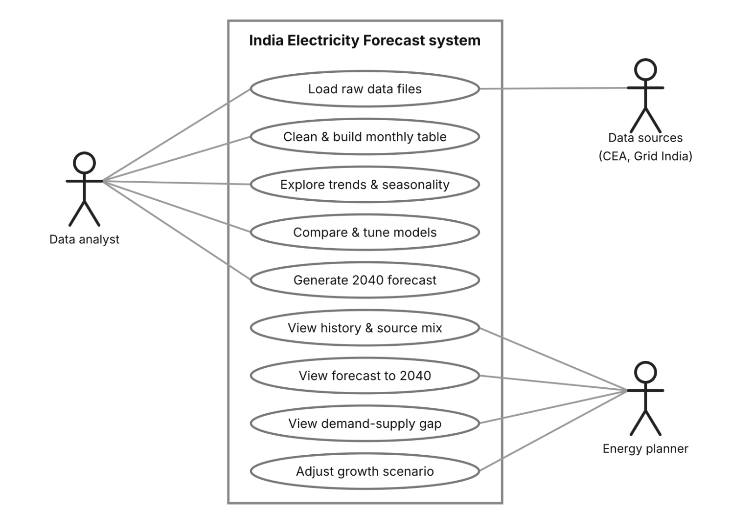
Figure 3.2: Use case diagram

Activity Diagram
The Activity Diagram shows the workflow from raw data to dashboard. The five files are loaded and harmonised, then aggregated to monthly averages. A decision step checks each month: if fewer than 20 days were reported, the month is flagged and interpolated, otherwise it is kept as it is. The prepared series is then used to fit and compare the models at each horizon, the SARIMA order is selected by AIC, and the final model forecasts to 2040. The forecast months are marked as validated or extrapolated, the demand-supply gap is computed, and the dashboard is updated.
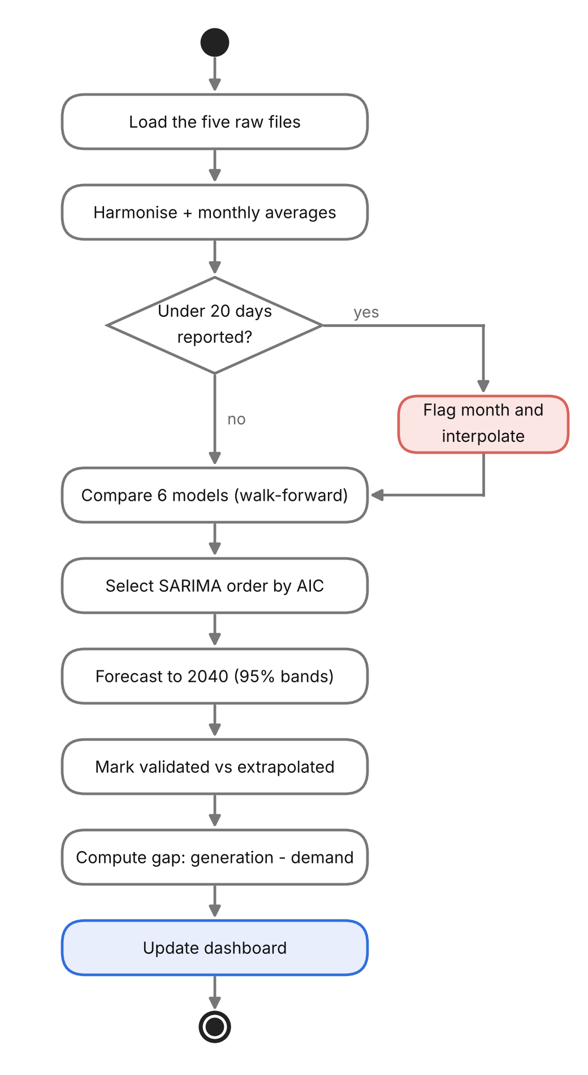
Figure 3.3: Activity diagram
3.3 Dataset and Data Design
Five public datasets are used, because no single file contains generation, demand, load, consumption and temperature together. Each file has a different time span and level of detail, and each is used for a specific purpose.
Dataset | Coverage | Detail | Role in the project
CEA daily power generation by source | Mar 2013 - Mar 2023 | Daily; 18,251 rows, 10 source labels | Total generation and source mix
Daily state-wise demand and energy met | Mar 2013 - Mar 2023 | Daily; 126,699 rows, 45 state or entity labels | National demand (energy met)
Hourly national and regional load | Jan 2019 - Apr 2024 | Hourly; 46,728 rows | Peak versus average demand
State-wise electricity consumption | Jan 2013 - Sep 2024 | Daily; 3,707 days, 36 states plus a total | Consumption
Monthly temperature (IMD-derived) | 2019 - 2021 | Monthly; 36 rows | Demand versus temperature
Table 3.1: Datasets used
All five sources are consolidated into one workbook of nine sheets: four raw sheets that preserve the original data, four intermediate sheets (harmonised generation by source, the national generation total, national daily demand and daily hourly-load summaries), and the final monthly table, MASTER_monthly. This table is the input to every analysis and forecasting step.
Column | Type | Meaning
year_month | period (monthly) | The month
avg_daily_generation | float, MU/day | Average daily national generation, from CEA’s reported Total
avg_daily_demand | float, MU/day | Average daily national energy met, summed over states
avg_daily_consumption | MU/day | Average daily consumption across states
avg_daily_coal_lignite, renewables, hydro, nuclear | float, MU/day | Average daily generation by source
days_reported_* | integer | Number of days with data for each metric in the month
monthly_peak_demand_mw | float, MW | Highest hourly national demand in the month
Monthly_load, max_temp | float | Monthly load and maximum temperature (36 months only)
low_coverage_flag | True / False | True if any core metric has fewer than 20 reported days
Table 3.2: Monthly modelling table (MASTER_monthly)
The series preparation step also adds lag, rolling-window, calendar and temperature columns to this table. The current SARIMA-based models use only the target series, so those extra columns are kept for future work with exogenous variables.
Data quality is protected in five ways:
- Reported totals are trusted: CEA’s own Total row is used as published and is never recomputed from its parts, which avoids double counting when parent categories (Thermal, RES) and their components (Coal, Wind, Solar) overlap.
- One category level per date: The itemised value is used when available, and the combined value is used otherwise, so each source forms one continuous series across the format change.
- Averages, not sums: Monthly values are average daily values, with a days-reported count kept beside each one, so a month with few reported days cannot create a false growth spike.
- Gaps are not zeros: Missing values stay missing. Before 26 May 2017, coal, nuclear and gas cannot be separated in the source, so they are left empty and a single residual group is kept instead. Source-mix shares are calculated only from December 2018, when all components are reported.
- Raw data is preserved: The raw sheets are never edited, so any cleaning step can be checked or reversed.

4. TOOLS AND TECHNOLOGIES
4.1 Programming Language - Python
Python is used for the whole pipeline: merging the raw files, cleaning, exploratory analysis, feature engineering, model fitting, validation, forecasting and the dashboard. It has mature libraries for every step of time series analysis and forecasting, and it reads and writes Excel and CSV files easily. Each stage of the project is a separate script, so the pipeline can be rerun in order from the command line.
4.2 Development Environment - Python Scripts / VS Code
The project is organised as a set of standalone Python scripts, one for each stage: consolidation, exploratory analysis, feature engineering, model comparison, SARIMA tuning, final forecast, gap analysis and the dashboard. Each script reads the output of the previous stage and saves its own output files, so any stage can be repeated without running the others. The scripts are run from the terminal, and the dependencies are listed in a requirements.txt file so the environment can be recreated. The code is kept in a Git repository on GitHub under the MIT license.
4.3 Data Storage - CSV / Excel / pandas
The raw data comes as CSV and Excel files: daily generation by source, daily state demand, hourly national load, state consumption and monthly temperature. The consolidation script merges them into one master Excel workbook with nine sheets. The raw sheets are kept untouched, next to the cleaned daily tables and the monthly table MASTER_monthly. The feature-engineering stage writes a 58-column features file, and each later stage saves its results as Excel files (model comparison, order search, forecasts and the demand-supply gap). pandas DataFrames with a monthly date index hold the series in memory, which makes resampling, interpolation, lags and rolling statistics simple.
4.4 Libraries and Technologies Used
The project uses the following Python libraries for data handling, time series modelling, visualization and the dashboard:
- pandas and NumPy: Loading the files, monthly aggregation (averages, not sums), day-coverage counts, interpolation, lags and rolling statistics.
- openpyxl: Reading and writing the Excel workbooks, including the multi-sheet master file.
- statsmodels:
  - SARIMAX for the final model, the 36-setting order search (AIC and BIC) and the 95% confidence bands.
  - ARIMA and ExponentialSmoothing (Holt-Winters) for the comparison models.
  - seasonal_decompose for the 12-month trend, seasonal and residual split.
- Matplotlib: The static charts used in the analysis and in this report: decompositions, growth rates, source mix, model accuracy by horizon and the forecast and gap plots.
- Plotly: The interactive charts inside the dashboard.
- Streamlit: The four-tab dashboard (Historical Trends, Source Mix, Forecast to 2040, Demand-Supply Gap), including the generation-growth slider.
- Baseline forecasters: The naive, seasonal naive and 3-month moving average models are written directly in Python and serve as the floor that the statistical models must beat.

5. IMPLEMENTATION
5.1 Project Modules
The project is divided into modules, each handling one stage of the pipeline. Each module is a separate Python script that reads the previous stage’s output and saves its own.
- Data Consolidation Module (consolidate_data_v2.py): Loads the five raw files, fixes the source-category hierarchy and builds the master workbook.
- Exploratory Analysis Module (eda_analysis.py): Produces the decompositions, growth rates, source-mix chart, temperature correlation and peak-demand analysis.
- Feature Engineering Module (feature_engineering.py): Fills gaps and adds lag, rolling, calendar, COVID and temperature features.
- Model Comparison Module (forecast_models.py, forecast_multihorizon.py): Compares six forecasting models with walk-forward validation.
- Model Tuning Module (sarima_order_search.py): Searches 36 SARIMA settings and selects the best by AIC.
- Forecasting Module (final_forecast.py): Fits the final SARIMA model and forecasts demand and generation to December 2040 with 95% bands.
- Gap Analysis Module (demand_supply_gap.py): Combines the two forecasts into the demand-supply gap.
- Dashboard Module (dashboard.py): Presents all results in an interactive Streamlit app.
5.2 Data Consolidation and Cleaning
The five raw files cover different periods and resolutions, so they were merged into one master workbook with nine sheets. The raw sheets are kept untouched, next to the cleaned daily tables and the monthly table MASTER_monthly, which has 140 rows and 19 columns. Four data problems were found by checking the data against itself, not by trusting that the code ran.

Table 5.1: Data problems found and fixes applied
Problem | What happened | Fix applied
Double counting | CEA changed its format, so parent rows (Thermal, RES) and part rows (Coal, Wind, Solar) appear on different dates. Summing every row counts power twice. | Use CEA’s reported Total; pick one category level per date
Reporting blackout | Around May 2017 the Total row is barely published: June and July 2017 have 0 days and May only 8 | Documented as a source gap; source mix starts Dec 2018, when all parts exist
Uneven coverage | Summing days made thin months look tiny, giving a false 630% YoY spike (Dec 2022 had 4 days); 9 months had under 20 days | Monthly averages instead of sums, plus a days-reported count per metric
Misleading share | Missing coal was counted as zero, so renewables looked like 23% in May 2017 and then “fell” to 11% | Gaps are no longer treated as zero in share calculations
5.3 Exploratory Analysis
The master table was explored with decomposition, growth rates and mix analysis. A 12-month additive decomposition splits demand and generation into trend, seasonal and residual parts. Year-over-year growth blanks the flagged months, compares each month with the same month a year earlier, and averages by calendar year. Red lines at 26 May 2017 mark the reporting-format change in every chart.
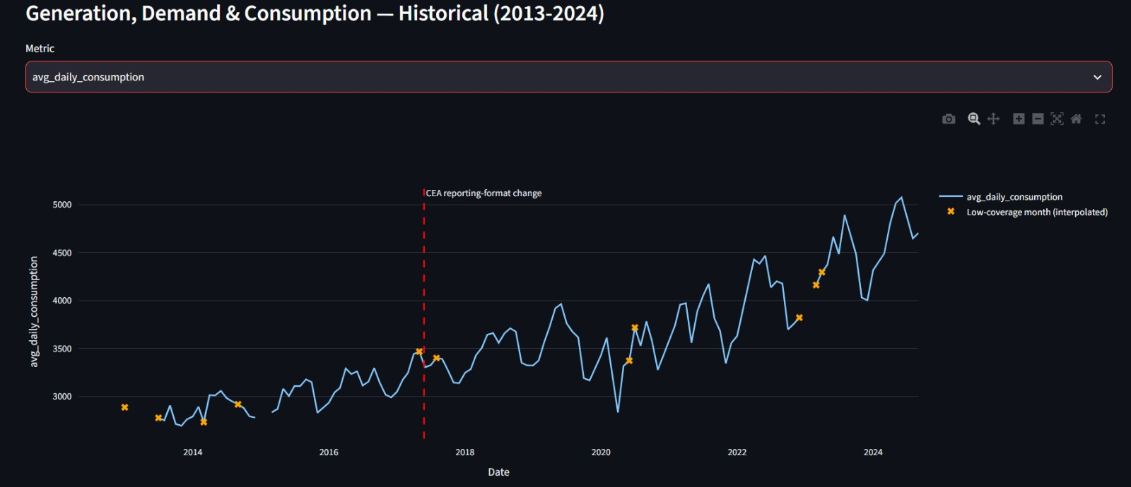
Figure 5.1: Year-over-year demand growth
Demand rises in most years and peaks from March to June because of air-conditioning load. It fell by about 25% year-over-year in April to June 2020 because of the COVID lockdown. The jump of about 40% in 2021 compares against that low base and is not a new boom. Real recovery growth in 2022 and 2023 was roughly 9 to 16% a year.
Table 5.2: Main exploratory results
Measure | Result | Interpretation
Coal share of generation | 65 to 80% | Coal stays dominant and dips each monsoon as hydro rises
Renewables share | 7.6% (Dec 2018) to 11.2% (Mar 2023) | Slow but steady growth
Demand vs temperature | r = 0.37 | Moderate, expected direction; only 36 months of temperature data
Peak above average demand | 9.17% (2019) to 10.34% (2023) | Demand is becoming peakier
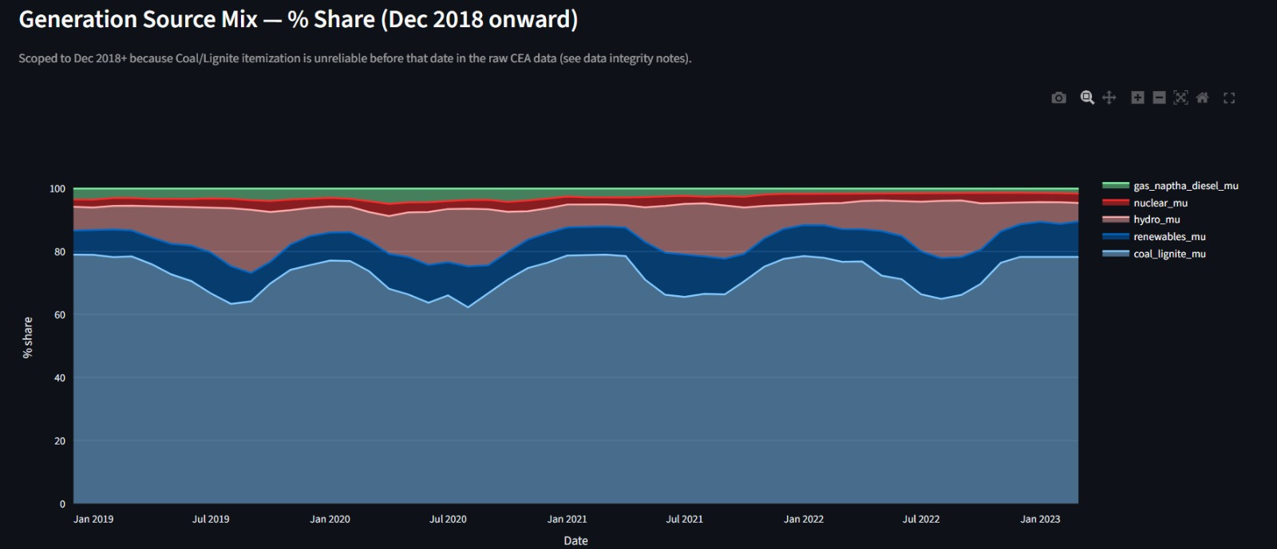
Figure 5.2: Source mix, December 2018 onward

5.4 Feature Engineering
Feature engineering prepares a model-ready table with 58 columns. The steps are:
- Fill gaps: Flagged months are blanked and then linearly interpolated, so the monthly index has no holes.
- Lags: Values 1, 3, 6 and 12 months back.
- Rolling statistics: Mean and standard deviation over 3, 6 and 12 months, calculated on past values only.
- Calendar features: Month, quarter, a summer-peak flag (March to June), and the sine and cosine of the month.
- COVID flag: April to June 2020 is marked as a one-off shock.
- Temperature: Missing months are filled with the average for the same calendar month.
5.5 Forecasting Models and Evaluation
Six models were compared, from simplest to most complex. Every model must beat the naive baselines to be worth keeping.
Table 5.3: Forecasting models
Model | Idea | Key settings
Naive | Repeat the last value | None
Seasonal naive | Same month last year | m = 12
Moving average | Mean of the last 3 months | Window = 3
Holt-Winters | Smoothed level, trend and season | Additive trend and season, period 12
ARIMA | Trend plus memory of past errors | (1,1,1)
SARIMA | ARIMA plus a yearly cycle | Chosen by AIC
The SARIMA model SARIMA(p, d, q)(P, D, Q)s with s = 12 is written as:
φp(B) ΦP(B^12) (1 − B)^d (1 − B^12)^D yt = θq(B) ΘQ(B^12) εt
Here B is the backshift operator (B yt = yt−1). The final model is SARIMA(1,1,2)(0,1,1,12): p = 1 uses last month’s change, d = 1 removes the trend, q = 2 corrects using the last two errors, D = 1 compares with the same month last year, and Q = 1 uses last year’s error.
A grid of 36 settings was searched (p and q from 0 to 2, P and Q from 0 to 1, with d = D = 1) and scored by AIC, which penalises unnecessary complexity.
Table 5.4: Best SARIMA settings by AIC
Order | Seasonal order | AIC | BIC
(1,1,2) | (0,1,1,12) | 1505.8 | 1519.4
(1,1,2) | (1,1,1,12) | 1506.5 | 1522.8
(0,1,2) | (0,1,1,12) | 1506.9 | 1517.9
(1,1,1) | (1,1,1,12) (original guess) | 1519.9 | 1533.6
The winning order scored about 14 AIC points better than the original guess. AIC is calculated on the fitting data, so it does not by itself prove forecast accuracy.
Validation. Shuffling a time series lets a model see the future, so every test uses walk-forward validation: train on all earlier months, forecast ahead, move forward and repeat. Accuracy is measured with MAE, RMSE and MAPE, where yt is the actual value and ŷt the forecast:
MAE = (1/n) Σ |yt − ŷt| RMSE = √[ (1/n) Σ (yt − ŷt)² ] MAPE = (100/n) Σ |yt − ŷt| / |yt|
Table 5.5: One-month-ahead test over 24 walk-forward folds
Model | MAE | RMSE | MAPE (%)
SARIMA | 96.8 | 133.5 | 2.38
ARIMA | 56.7 | 135.8 | 1.44
Holt-Winters | 106.6 | 140.8 | 2.62
Naive | 49.1 | 148.1 | 1.28
Moving average | 71.5 | 163.2 | 1.83
Seasonal naive | 159.4 | 234.4 | 3.88
SARIMA has the lowest RMSE, but Naive and ARIMA score better on MAE and MAPE. This is partly because 20 of the 24 test months are the flat filled values, which a naive model predicts almost perfectly.
Because the target is a forecast up to 2040, accuracy was also tested at longer horizons. The walk-forward was repeated from 12 different start dates for horizons of 1, 3, 6, 12 and 24 months.
Table 5.6: MAPE (%) by forecast horizon
Model | 1 mo | 3 mo | 6 mo | 12 mo | 24 mo
SARIMA | 3.41 | 5.88 | 3.87 | 7.73 | 8.62
Holt-Winters | 3.48 | 7.09 | 4.28 | 7.91 | 9.83
ARIMA | 3.67 | 7.54 | 7.22 | 5.99 | 9.85
Naive | 3.62 | 8.98 | 8.14 | 6.82 | 9.79
Seasonal naive | 5.89 | 6.81 | 5.32 | 6.82 | 9.79
5.6 Forecast to 2040 and Demand-Supply Gap
The final SARIMA(1,1,2)(0,1,1,12) model was fitted separately to average daily demand and to average daily generation. Each model forecasts 195 months, from October 2024 to December 2040, with a 95% confidence band. Only the first 24 months are counted as validated, which leaves 171 of 195 months (88%) as trend extrapolation.
Table 5.7: Forecast checkpoints (December of each year, average daily MU)
Year | Demand | Generation | Gap | Worst case | Best case
2026 | 4,335 | 4,739 | +405 | −1,025 | +1,834
2030 | 4,899 | 5,433 | +534 | −1,768 | +2,837
2035 | 5,605 | 6,301 | +696 | −2,653 | +4,044
2040 | 6,311 | 7,168 | +858 | −3,520 | +5,236
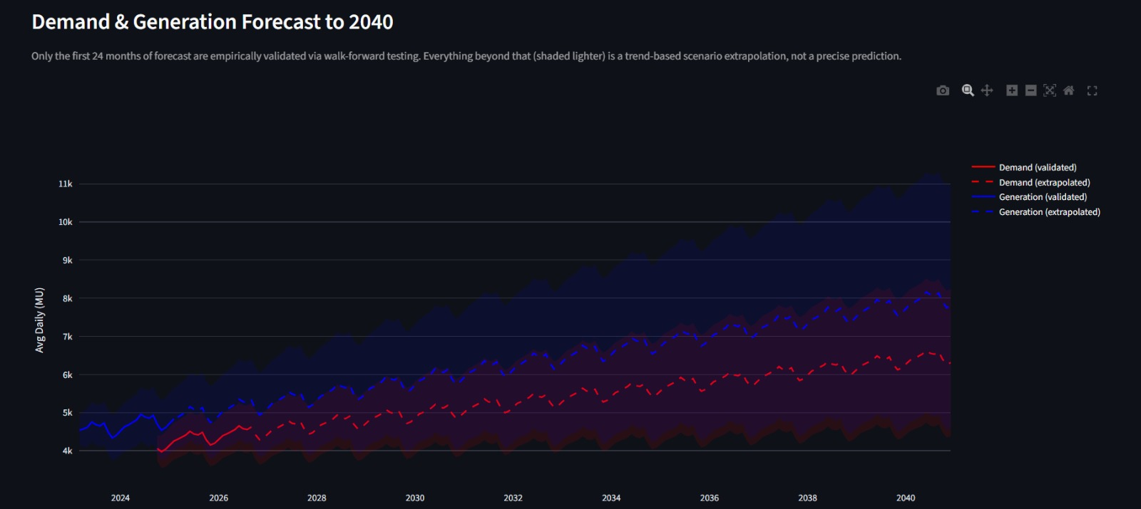
Figure 5.3: Demand and Generation forecast
5.7 Dashboard
The results are presented in an interactive Streamlit app with four tabs.
- Historical Trends: Generation, demand or consumption from 2013, with low-coverage months marked and the 2017 reporting-format change shown as a red line.
- Source Mix: The shares of coal, renewables, hydro, nuclear and gas from December 2018, with the first and latest renewables share.
- Forecast to 2040: Demand and generation with 95% bands, drawn solid for the validated horizon and dashed for extrapolation, plus a table of checkpoint values.
- Demand-Supply Gap: The gap with a slider that shifts generation growth from −5% to +5% a year, plus a warning that the worst and best cases assume independence.
6. TESTING
6.1 Test Cases
Testing checks each stage of the pipeline. Each test case has a unique ID, the scenario tested and the expected result.
Table 6.1: Test cases
Test Case ID | Test Scenario | Expected Result
TC01 | Load the five raw files in the consolidation script | Every file is read; the master workbook is saved with 9 sheets
TC02 | Build the monthly master table | 140 monthly rows and 19 columns, one row per month
TC03 | Generation total for a date with both parent and part rows | CEA’s reported Total is used once; no double counting
TC04 | Month with fewer than 20 reported days in a core metric | low_coverage_flag is set; 12 months are flagged
TC05 | Year-over-year growth for a flagged month | Value is blanked, so no false spike (such as the 630% in Dec 2022)
TC06 | Source mix before December 2018 | Not plotted, because the part-level rows do not exist yet
TC07 | Fill missing monthly values in feature engineering | Monthly index has no gaps; features file has 58 columns
TC08 | Rolling statistics on a month | Calculated from past values only, with no look-ahead
TC09 | Walk-forward split | Every test month is later than every training month; time is never shuffled
TC10 | Run all six models in the comparison | MAE, RMSE and MAPE returned for each model at every horizon
TC11 | Order search over the SARIMA grid | 36 settings scored by AIC and BIC; best setting saved to Excel
TC12 | Final forecast to December 2040 | 195 monthly forecasts per series, each with a 95% band
TC13 | Demand-supply gap calculation | Gap = generation − demand; worst and best cases saved for all 195 months
TC14 | Refit with lbfgs, powell and Nelder-Mead | Three 2040 values returned so the spread can be measured
TC15 | Start the Streamlit dashboard and open each tab | Four tabs load; the gap slider changes the adjusted gap curve
6.2 Results and Debugging
All stages were tested end to end on the real data. Most of the issues below were found by checking the data against itself and are not code errors. The pipeline ran without crashing in every case. The numbers were wrong and had to be explained.
Fixed during development
- Double counting: Summing all CEA rows counted the same power twice, because parent rows (Thermal, RES) and part rows (Coal, Wind, Solar) appear on different dates. The script now uses the reported Total.
- Reporting blackout: The Total row is almost missing around May 2017: June and July 2017 have 0 days and May has 8. This is a gap in the source, so it is flagged and documented, and the source mix starts in December 2018.
- False growth spike: Summing days made a month with 4 reported days (December 2022) look tiny, so the following year showed 630% growth. Monthly averages and the days-reported count fixed this.
- Missing parts counted as zero: With coal missing, renewables looked like 23% of generation in May 2017, then appeared to fall to 11%. Gaps are no longer treated as zero in share calculations.
- Live APIs: All 11 tested CEA endpoints timed out and data.gov.in needed a key, so the project uses downloaded files.
- Non-converging orders: The (2,1,2) SARIMA settings did not converge in the order search. They did not win, so the selected model was not affected.

7. CONCLUSION
7.1 Summary
This project forecasts India’s monthly electricity demand and generation to 2040 and compares the two to estimate the demand-supply gap. It started with five raw files that cover different periods, use different formats and disagree about what counts as a total. Merging them into one master workbook meant finding and fixing four data problems: double counting between parent and part rows, a reporting blackout around May 2017, uneven monthly coverage and missing parts counted as zero. Twelve months with thin coverage were flagged and kept out of growth calculations.
Exploratory analysis showed a clear picture of the system. Demand peaks from March to June because of cooling load and fell by about 25% in the 2020 lockdown. The 40% jump in 2021 compared against that low base and was not a new boom. Coal stays at 65 to 80% of generation, renewables grew from 7.6% to 11.2% between December 2018 and March 2023, and peak demand is becoming peakier.
Six forecasting models were compared with walk-forward validation. SARIMA was best at four of the five horizons tested, and a grid search of 36 settings chose SARIMA(1,1,2)(0,1,1,12) by AIC (1505.8). The final model forecasts 195 months to December 2040 with 95% bands. It gives demand of 6,311 MU a day and generation of 7,168 MU a day in 2040, a central gap of +858 MU a day. Generation grows slightly faster than demand (about 3.1% against 2.8% a year), so the central gap stays positive in every month. The results are presented in a four-tab Streamlit dashboard with a slider for testing different generation growth rates.
The project also states what the forecast cannot show. Only the first 24 of the 195 forecast months are validated, and the 95% band widens from ±14% in 2025 to ±31% in 2040. The final audit found that the series was padded with 19 copies of the last real value, so the model tests and the forecast start point are affected. It also found that part of the surplus is a measurement offset between plant-level generation and state-level demand. The 2040 numbers should therefore be read as a trend scenario and not as a precise prediction or a measure of spare capacity. The planned fix is known (interpolate only inside the real data range, flag each metric separately, and rerun the pipeline), and the corrected numbers will replace the ones in this report.
7.2 Future Enhancements
- Fix the padded series. Stop filling past the end of the real data, keep the seven good months that were blanked, and rerun the order search, validation and forecast.
- Update the data. The real data ends in March 2023, so refreshing it to the present would shorten the extrapolated stretch of the forecast and make the validation meaningful.
- Add outside drivers. Test SARIMAX with temperature, GDP, population, renewable capacity additions and electricity prices, instead of the target series alone. The features file is already built for this.
- Use count and ratio models. Compare against methods that handle growth differently, such as ETS with damped trend, Prophet with changepoints and gradient-boosted models on the engineered features.
- Replace the independent worst case. Build the gap band from a joint model of demand and generation, or by simulation, so the worst and best cases reflect how the two actually move together.
- Break down by region and source. Forecast by state or grid region, and forecast each generation source (coal, solar, wind, hydro) separately to see how the mix changes toward 2040.
- Add scenarios. Turn the dashboard’s growth slider into proper policy scenarios, such as faster renewable build-out or a demand shock from electrification.
- Add a shock accountant. Extend the project with an “Electricity Shock Accountant” that measures how much of a given month’s change comes from one-off events such as COVID or heatwaves, and how much from trend.
- Automate the pipeline. Combine the scripts into one command with automatic checks, such as a data-coverage report and a test that fails if the last rows are identical, so this kind of problem is caught early.

8. REFERENCES
- Tashman, L. J. (2000). Out-of-sample tests of forecasting accuracy: an analysis and review. International Journal of Forecasting, 16(4), 437-450.
- Seabold, S. & Perktold, J. (2010). statsmodels: Econometric and statistical modeling with Python. Proceedings of the 9th Python in Science Conference. https://www.statsmodels.org/
- McKinney, W. (2010). Data structures for statistical computing in Python. Proceedings of the 9th Python in Science Conference. https://pandas.pydata.org/
- Harris, C. R. et al. (2020). Array programming with NumPy. Nature, 585, 357-362. https://numpy.org/
- Hunter, J. D. (2007). Matplotlib: A 2D graphics environment. Computing in Science & Engineering, 9(3), 90-95. https://matplotlib.org/
- Streamlit Inc. Streamlit documentation. https://docs.streamlit.io/
- Plotly Technologies Inc. Plotly Python graphing library. https://plotly.com/python/
- Central Electricity Authority (CEA), Ministry of Power, Government of India. Daily generation reports and power supply position. https://cea.nic.in/
- Grid Controller of India Limited (Grid India, formerly POSOCO) and Regional Load Despatch Centres. Daily and hourly demand and load data. https://grid-india.in/
- India Meteorological Department (IMD). Temperature data. https://mausam.imd.gov.in/

